Develop() Design Document

Table of Contents

Overview 1

Wireframes 1

Use Case Description 4

Development Blog 4

Photo Gallery 4

Top-Rated Posts 4

Database Design 5

# Overview

Develop() is a simple web application created for the Winter 2015 Internet Software course at the British Columbia Institute of Technology.

The primary goal of Develop() is to chronicle the progress of the Data Communications term project in a number of unique ways that may be both interesting and useful to members of the team, as well as others who are not involved.

Develop() contains an active blog page on which posts about the project's progress are made. Additionally, Develop() has a page devoted entirely to showcasing photos and images related to the project. The final method Develop() uses to showcase the project is a page that displays the blog posts sorted in order of top-rated to lowest-rated.

# Wireframes

Our wireframe designs were completed in three passes. The first pass was our initial draft and concept of the web application. The second was a revision that added a third use case to the web app and cleaned up (and simplified) some of the functionality. The third pass was a revision that changed the GitHub API page to a top-rated blog posts page due to the complicated nature of the GitHub API and the fact that it was not officially available for PHP.

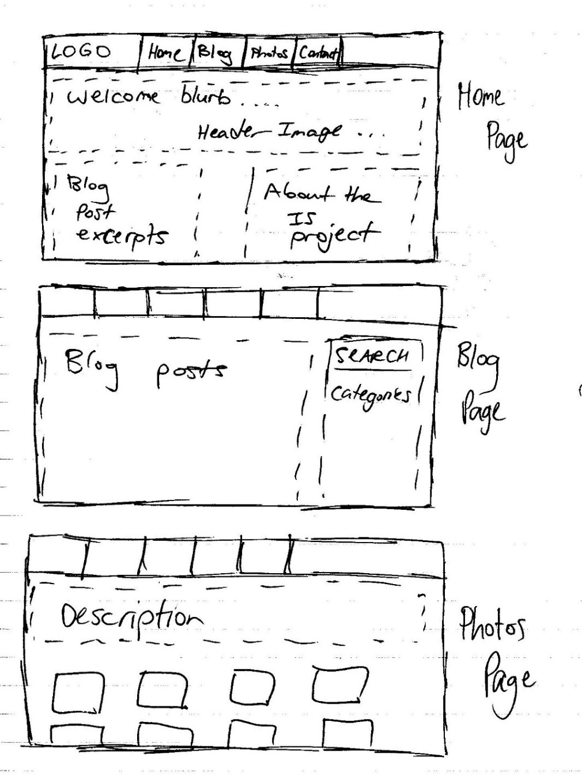

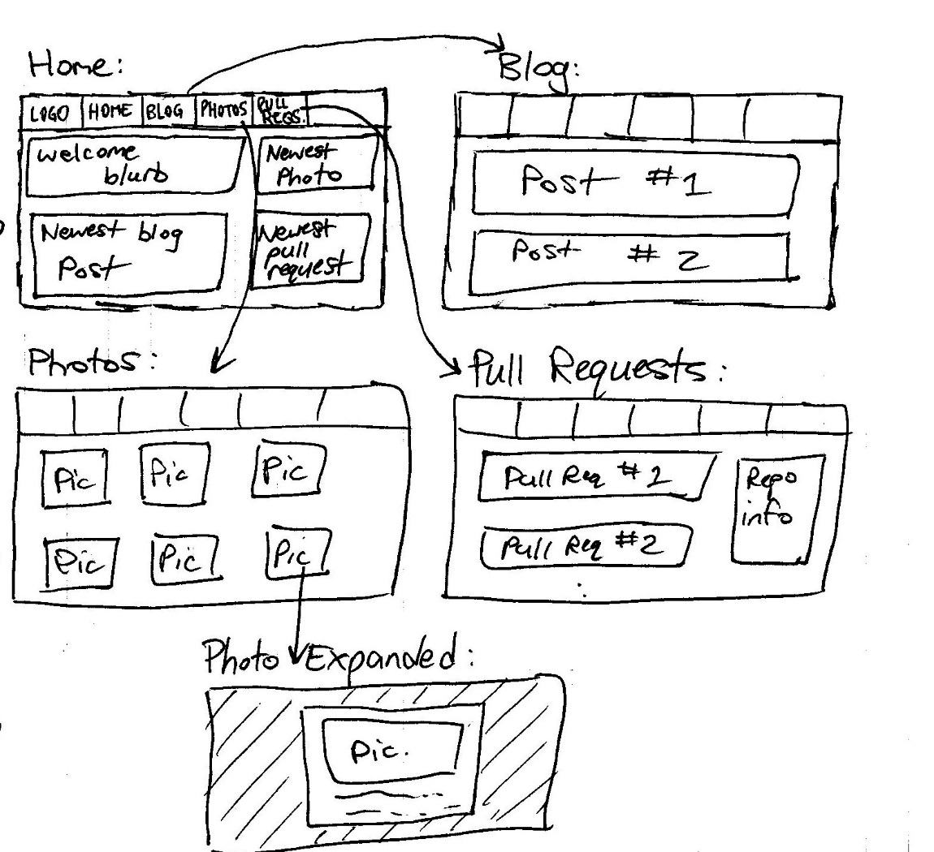

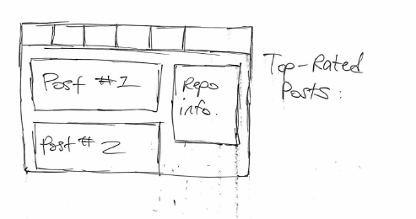

# Use Case Description

Our application currently has three primary use cases, each corresponding to a page in the web app. Each of these use cases displays a different type of content related to the Data Communications term project.

Ultimately, this web app will have four use cases, but the fourth one will not be completed until the second assignment.

## Development Blog

The Development Blog use case deals with accessing and viewing the development blog page of the web application. This page can be accessed from the navigation bar, and displays all of the blog posts in order of most recently added.

These blog posts contain information about the author, the author's avatar, the post's content and the time and date submitted. This data will likely be stored in an SQL relational database, and will be accessed both on the blog page, as well as the home page, where the most recent post will be previewed.

## Photo Gallery

The Photo Gallery use case deals with the photos page of Develop(). The photos page displays a grid-view of every photo and image captured of the project's progress. These photos will be clickable, and will expand into a light-box view where they can be seen at full size.

Each photo will have a short description that will be viewable in the light-box view. This content will be saved in an SQL relational database.

## Top-Rated Posts

The Top-Rated Posts use case also deals with blog posts contributed to Develop(). This page displays blog posts in order of highest-rated to lowest-rated in order to show viewers what is considered to be the most interesting, valuable or engaging content related to the project.

# Database Design

Our web app features two full SQL tables. In order to ensure that these tables were designed properly, we completed some simple designs. These designs may change once we implement the tables properly (ie. More than just 2D arrays), but for now they represent the data that we want to store.

